Structural Frame Analysis
with the Finite Element Method (FEM)

Bauhaus-Universität Weimar, Informatik im Bauwesen

2009
Contents

1 Formulation of the Finite Element Solution 4
2 Implementation on the basis of the FEM Framework 6
2.1 Main programs for structural analysis: 8
2.2 Parsing persistent model information (input file) 10
2.3 Model information for the analysis 22
2.3.1 establishing element matrices 22
2.3.2 defining material properties 24
2.3.3 defining external influences on the system 25
2.3.4 defining support conditions 26
2.3.5 defining information for time integration 26

Formulation of the Finite Element Solution
The analysis of problems in beam analysis consists of the Finite Element approximation of the system equations with a corresponding formulation of the element equations, the influences on the model (loads), the constitutive relations (material properties) and the external support conditions.
Furthermore, a specific element must be chosen that is appropriate for the problem to be solved defining the geometry of the problem (element geometry) and the element characteristics for the model.
The differential form of the system equation governing the behaviour of general beam elements in structural analysis is given as follows (see for example: [3]):
structural frameworks (1-dimensional) with
axial deformation (truss),
bending deformation (beams, frames)
are commonly modelled by the
differential equation for axial deformation | 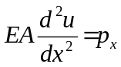
and bending deformation | 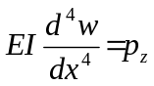
The integral form of the beam equations for all elements is given by, s. [2]:
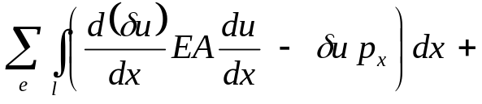
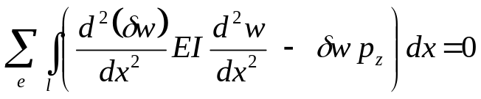

The FEM approximation of the integral form is achieved by approximation of the deformation via form functions S(x)
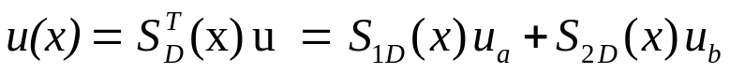

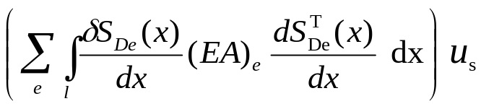 | element matrices for axial deformation  (trusses)
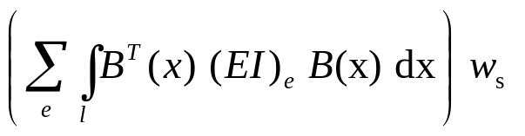 | element matrices for bending deformation

Depending on the type of elements and interpolation functions chosen this will result in a different set of linear equations of the form:
K_{s}u_{s} = p_{s} - q_{s}

The system matrix K_{s} is multiplied by the vector of nodal deformations u_{s} referred to as primal system vector. The Right-Hand-Side (RHS) consists of the external influences on the system referred to as load vector p_{s} and of the support conditions on the system q_{s} referred to as dual system vector.

Model information for the analysis
Model information for the analysis of problems in structural analysis (beam theory) consists of the Finite Element approximation defining the element equations, the influences on the model (loads), the constitutive relations (material properties) and the external support conditions.
Furthermore, a specific element must be chosen that is appropriate for the problem to be solved defining the geometry of the problem (element geometry) and the element characteristics for the model.
Each application that is defined in the context of the FEM Framework simply needs to implement the additional application specific functionality for
- the element matrices,
- the material properties,
- the external influences on the model,
- the support conditions for the model and
- the time integration information.
These classes will be used by the parser in order to generate application specific objects.

establishing element matrices
Functionality that is required for 2-dimensional linear truss elements in structural analysis is collected in class Truss.
Class Truss defines static attributes for the number of nodal degrees of freedom, the stiffness matrix, the mass matrix, the element deformations and the vector of the truss end forces.
The corresponding classes will be used by the parser in order to generate application specific objects.
A constructor is defined for generating new truss elements on the basis of identifiers for a new truss element, element nodes, cross section, material and the number of nodal degrees of freedom.
Class Truss is a simple element for linear truss analysis in two dimensions. It will be derived from abstract class AbstractLinear2Node2D.
Evaluation of the element matrix starts with the computation of the geometry, evaluation of the factor 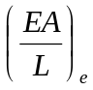 and the shape function vector for each truss element. This is followed by the computation of the corresponding element matrix:
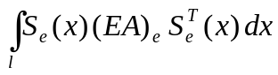
The diagonal mass matrix is stored in vector format. It is defined by the product of the specific mass with half the volume of the element for each node in each direction:
diagonal terms of 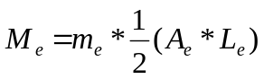
The behaviour of truss elements is defined by the computation of end forces and element deformations. Evaluation of end forces starts with re-computation of element geometries, computation of element displacements in local coordinates and evaluation of:
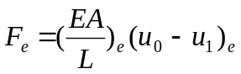
Functionality that is required for 2-dimensional linear beam elements in structural analysis is collected in class Beam and class HingedBeam.
Class Beam defines static attributes for the stiffness matrix, the mass matrix, the vector of the beam end forces, the element deformation vector, the shape function vector, the load vector and the value of the Gauss integration point.
The corresponding classes will be used by the parser in order to generate application specific objects.
A constructor is defined for generating new beam elements on the basis of identifiers for a new beam element, element nodes, cross section, material and the number of nodal degrees of freedom.
Class Beam is defined for linear beam analysis in two dimensions. It will be derived from abstract class AbstractLinear2Node2D.
Evaluation of the element matrix starts with the computation of the local matrix
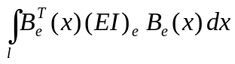
which is subsequently transformed to global coordinates.
The diagonal mass matrix is stored in vector format. It is defined by the product of the specific mass with half the volume of the element for each node in each direction:
diagonal terms of
The element load vector is evaluated for element point loads or line loads depending on the type of abstract element load given as parameter. Loads may either be defined in global or in local element coordinates which is indicated by a flag in the parameter list. Interpolation of loads is carried out on the basis of the shape function vector at a specific point.
The behaviour of beam elements is defined by the computation of end forces and element deformations. Evaluation of end forces starts with computation of the local element matrix followed by computation of element deformations in local coordinates. End forces are then computed with contributions from nodal element deformations and contributions from point and line loads for a beam element.
Class HingedBeam is derived from class Beam. It distinguishes between a hinge at the start (FIRST) or at the end node (SECOND) and computes the corresponding element matrix via static condensation of the rotational degree of freedom released from the system. For this purpose a “type” attribute is added to the constructor as an integer value.

defining material properties
The material description in structural analysis is given in general by the elasticity matrix E. In beam theory material properties required for evaluation of the element matrix are:
E Young’s modulus of elasticity and
ν Poisson’s ratio

For evaluation of the element mass matrix the additional value required is:
m specific mass

Class Material is contained in package structuralAnalysis.model and imports class model.implementation.AbstractMaterial. It is derived from class AbstractMaterial.
It consists of three constructors for passing the material identifier to the model and for storing the material property under names “emodulus”, “poisson” and “mass” and it provides methods for retrieving the material properties (getModulusOfElasticity, getPoissonRatio and getMass).

defining external influences on the system
External influences on the model can either be defined as
- nodal influences
are concentrated loads at the nodes of the element mesh. The intensity of the load is given. The intensity is positive in positive coordinate directions.
- line influences
are line loads between two neighbouring nodes of the element mesh. The line load intensities are defined. If the line load intensity varies linearly along the line, the intensities at the end nodes are given.

Class NodeLoad contains the implementation of nodal load influences. It is derived from class AbstractNodeLoad. Constructors are defined by specifying an identifier for the node load and for the node the load is applied to and by specifying the values for load intensities at the node in x-and y-direction (p_{x}, p_{y}) and optionally the rotational moment M.
Class LineLoad contains the implementation of line load influences. It is derived from class AbstractElementLoad. Constructors are defined by specifying an identifier for the node load and for the element the load is applied to and by specifying the values for load intensities at the start and end node in x-and y-direction (p_{x}, p_{y}) either in local or global coordinates

defining support conditions
Support conditions for the model can be defined for each node. Since nodes in structural analysis have three degrees of freedom, the prescribed values at a node need to be defined and the system status vector needs to be adjusted.
Class Support is contained in package structuralAnalysis.model. It is derived from class AbstractSupport and needs to implement interface ISupport.
Each support object provides attributes for the types of support conditions (x-direction, y-direction or rotation restrained), the vector of reaction forces, the vector of prescribed deformations, the vector of time varying deflections and a boolean vector indicating locations of element restraints.
The constructor is defined by 2 string identifiers for the support and the associated node, by an integer value for the support type and by a vector of predefined nodal deformations.
The support type is defined for x-direction, y-direction and rotation restraint with
1 x(direction) fixed, 2 y(direction) fixed, 3 xy fixed, 4 r(otation) fixed,
5 xr fixed, 6 yr fixed and 7 xyr fixed.
Interface ISupport requires implementation of methods setReactions, getNode, getRestraint, getPrescribed, getTimeDependent, getTimeVariation and getNodeId.

defining information for time integration
Time integration information for the model can be defined for different time integration objects. Time integration objects are defined to store all the relevant information for a specific time integration problem in the model.

Time integration information for the model can be defined for different time integration objects each having a specific identifier (id). Time integration objects are defined to store all relevant information for a specific time integration problem in the model.
Two constructors are provided, one defining the time integration id, the time step, the method to be used, parameter1 and parameter2 for the specific method, the displacement matrix, the velocity matrix and the forcing function matrix. The second constructor will define an additional diagonal damping matrix.
Displacement, velocity and forcing function matrices will store nodal values for all nodes at each time step while the velocity matrix only stores values at the current and the immediately preceding step.

